
LESSON NOTE | DETAILED EXPLANATORY NOTES
GENETICS & MOLECULAR BIOLOGY
TRANSCRIPTION & TRANSLATION
GRADE 12 - BIOLOGY

■ ■ ■

“A gene is silent until it is read aloud. Transcription whispers its message into RNA; translation turns that message into the working machinery of life.”

What Is the Central Dogma?
The central dogma of molecular biology (proposed by Francis Crick, 1958) describes how genetic information flows in a cell: DNA → RNA → protein. DNA is the permanent store of instructions; it is copied into a working message (mRNA) by transcription; and that message is decoded into a protein by translation. Proteins then do the work of the cell - as enzymes, structures, hormones and more.
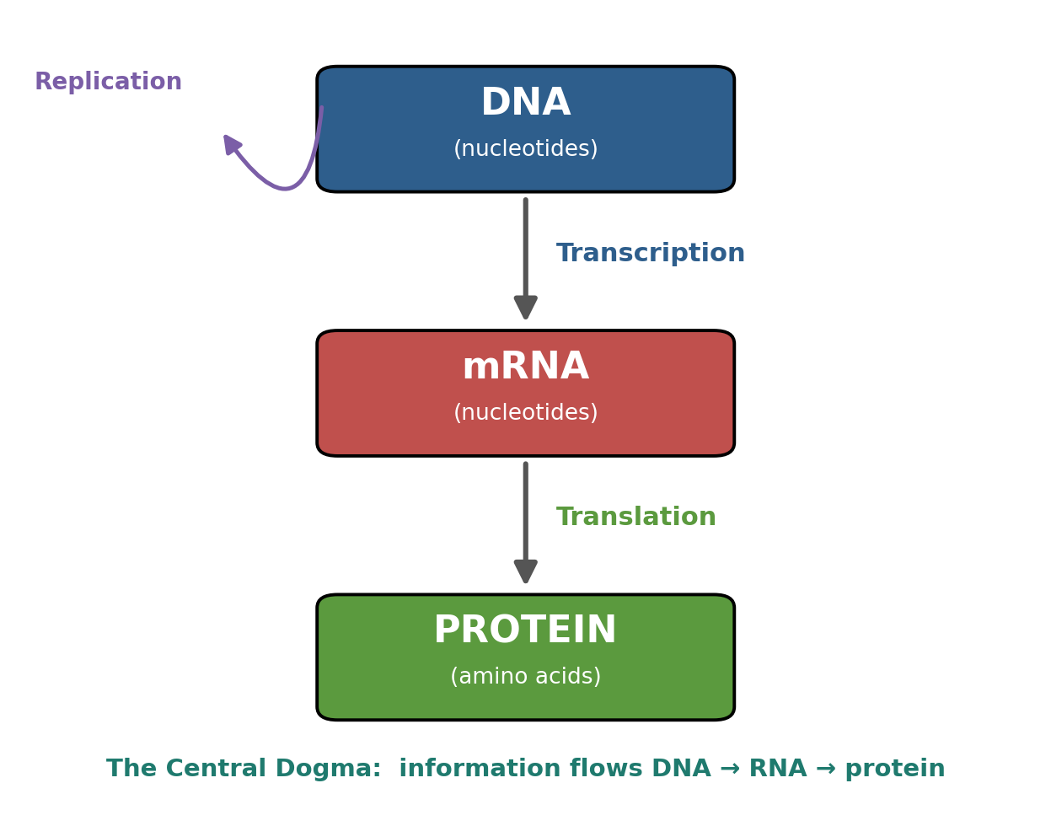
Figure 1: The central dogma - information flows from DNA to RNA to protein.

Key Learning Outcomes
- State the central dogma (DNA → RNA → protein) and explain its importance.
- Define gene expression and explain how genetic information makes proteins.
- Define transcription and describe how mRNA is made from a DNA template (role of RNA polymerase).
- Explain the genetic code: codons, the start codon and stop codons.
- Describe the roles of mRNA, tRNA and rRNA in protein synthesis.
- Describe translation and its stages: initiation, elongation and termination.
- Use a codon to work out the amino acid it encodes.

Gene Expression and the Key Molecules
Gene expression is the whole process of using the information in a gene to make a functional product (usually a protein). Although every cell has the same DNA, different genes are switched on or off in different cells - which is why a nerve cell and a skin cell are so different.
Three kinds of RNA do the work:
- mRNA (messenger): carries the coded message from the DNA in the nucleus to the ribosome.
- tRNA (transfer): brings the correct amino acid to match each codon.
- rRNA (ribosomal): makes up the ribosome, the machine that builds the protein.
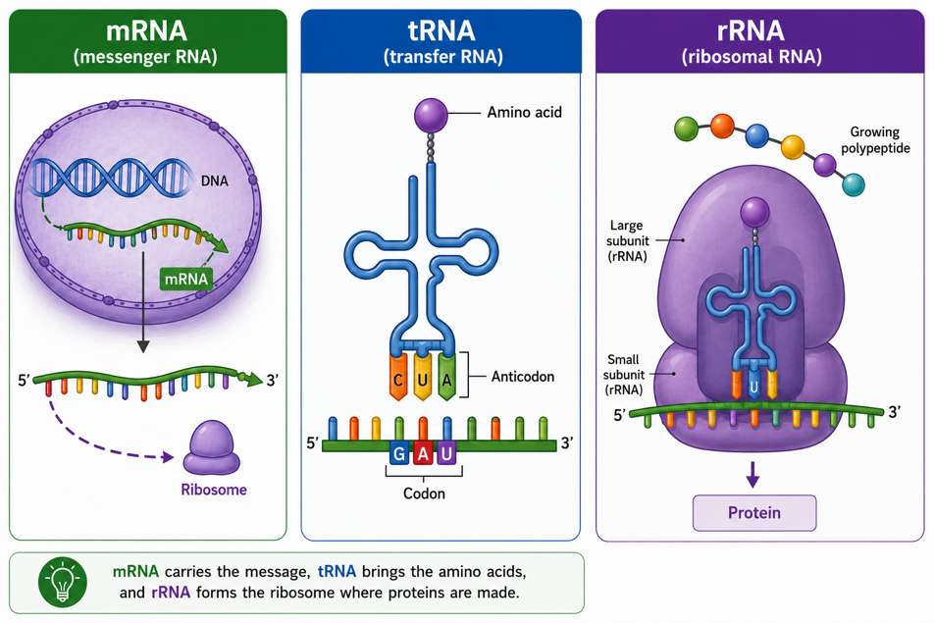
Figure 1: The three types of RNA work together to convert genetic information into proteins.

Transcription - Making the mRNA
Transcription happens in the nucleus. The enzyme RNA polymerase binds to the start of a gene, unwinds the DNA, and reads one strand (the template strand). It builds a complementary strand of mRNA, pairing bases as A–U, T–A, C–G, G–C - note that RNA uses uracil (U) in place of thymine. The finished mRNA leaves the nucleus and travels to a ribosome.
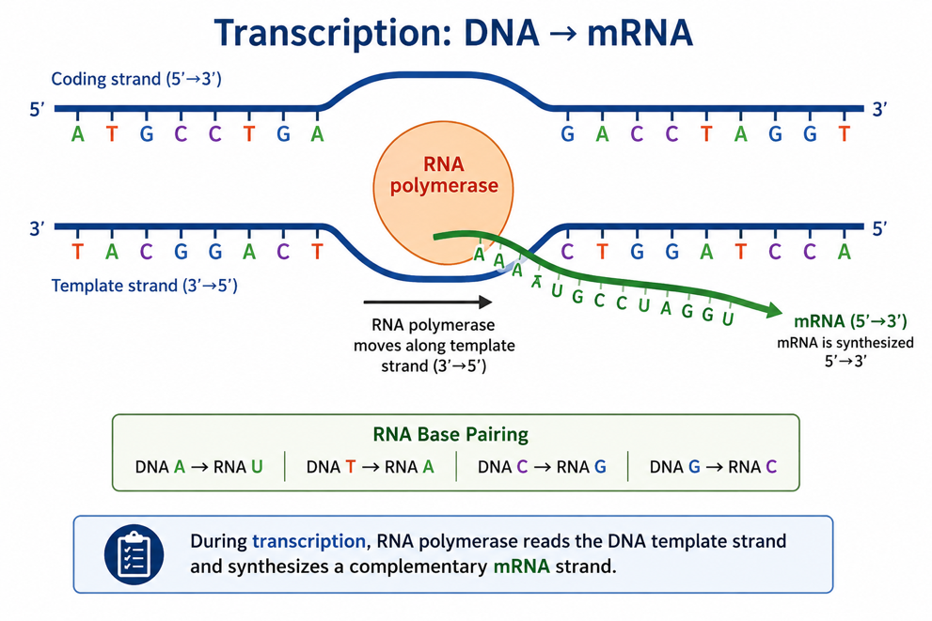
Figure 2: RNA polymerase copies the gene’s template strand into a new mRNA molecule.

The Genetic Code
The mRNA message is read in threes. Each group of three bases is a codon, and each codon stands for one amino acid. There are 64 codons for 20 amino acids, so the code is a little repetitive (several codons can mean the same amino acid). Two special signals control the message:
- Start codon - AUG (also codes for the amino acid methionine): tells the ribosome where to begin.
- Stop codons - UAA, UAG, UGA: tell the ribosome to finish; they code for no amino acid.
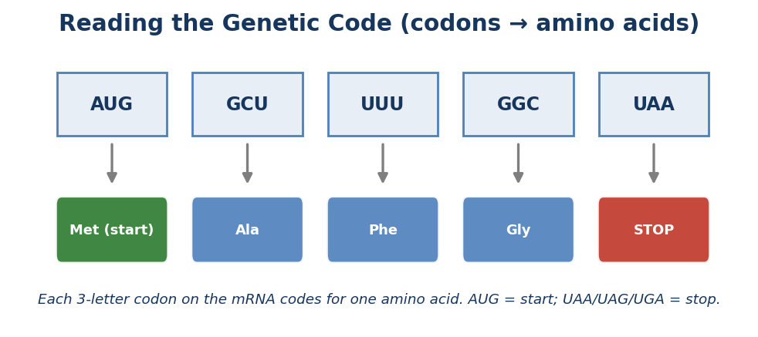
Figure 3: Reading codons - each three-letter codon codes for one amino acid.

Translation - Building the Protein
Translation happens at the ribosome. The ribosome moves along the mRNA reading each codon. A matching tRNA - carrying the right amino acid and bearing the complementary anticodon - pairs with each codon, and the amino acids are joined into a chain. It happens in three stages:
- Initiation: the ribosome assembles on the mRNA at the start codon (AUG).
- Elongation: tRNAs deliver amino acids one by one; the growing chain lengthens.
- Termination: a stop codon is reached; the finished polypeptide (protein chain) is released.

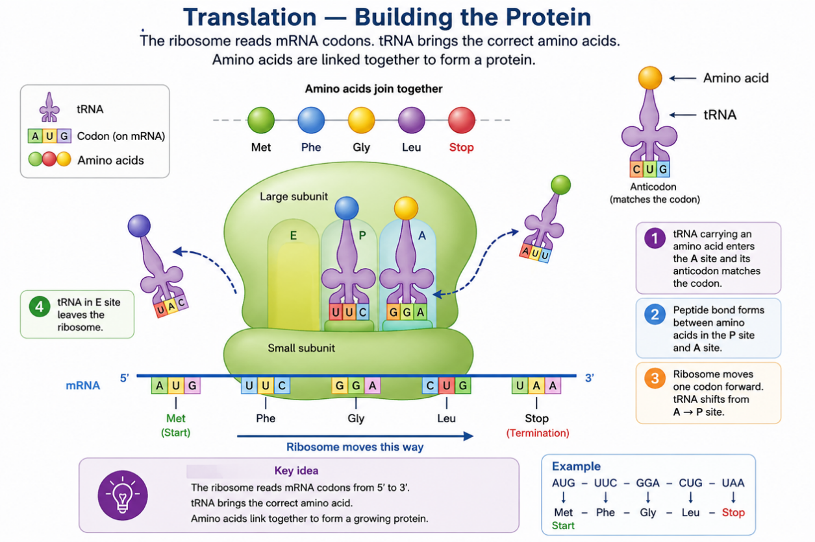

Figure 4: The ribosome reads mRNA and tRNAs deliver amino acids to build the protein.

The new chain then folds into a 3-D shape to become a working protein. A change in the DNA (a mutation) can change a codon and so change the protein - sometimes harmlessly, sometimes causing disease such as sickle-cell anaemia.

Why It Matters
Transcription and translation drive growth, repair and all cell activities. They are also the basis of biotechnology: because we understand how genes are expressed, we can read gene sequences, and even insert a useful gene into bacteria so they make a human protein the subject of the next les-son, Recombinant DNA Technology.

PNG relevance
Understanding gene expression underpins medical diagnosis (DNA and disease testing), agriculture (improving PNG crops), and the Grade 12 Biotechnology strand — opening pathways to science and health careers.

Key Vocabulary
- Central dogma - The flow of genetic information: DNA → RNA → protein.
- Gene expression - Using a gene’s information to make a functional product.
- Transcription - Copying a gene into messenger RNA (mRNA).
- RNA polymerase - The enzyme that builds mRNA from a DNA template.
- Template strand - The DNA strand that is read during transcription.
- mRNA / tRNA / rRNA - Messenger / transfer / ribosomal RNA.
- Codon - A group of three mRNA bases coding for one amino acid.
- Anticodon - The three bases on a tRNA that pair with a codon.
- Start / Stop codon - AUG begins translation; UAA/UAG/UGA end it.
- Translation - Decoding mRNA at the ribosome to build a protein.
- Polypeptide - A chain of amino acids that folds into a protein.
- Mutation - A change in DNA that can change the protein made.

Check Yourself
- State the central dogma and explain what happens at each arrow.
- What is gene expression, and why are different genes active in different cells?
- Describe transcription, naming the enzyme and the base-pairing rules (remember U).
- What is a codon? How many bases is it, and what does it code for?
- Give the start codon and the three stop codons, and say what each does.
- State the jobs of mRNA, tRNA and rRNA.
- Describe the three stages of translation.
- Using the codons AUG-GCU-UAA, work out the amino-acid sequence (use: GCU = Ala).
- How can a mutation in DNA change a protein? Give one example of a resulting disease.
- Why are transcription and translation important for biotechnology?

References
- Department of Education, Papua New Guinea. STEM Biology Syllabus - Grade 12: Biotechnology › Bioinformatics (Central Dogma; transcription and translation).
- Department of Education, Papua New Guinea. Biology Syllabus, Grades 11 & 12 (SBC) - Strand 2 (Life), Unit 2: Genetics, benchmark 12.2.2.3.
- Crick, F. (1958/1970). On the central dogma of molecular biology.
- OpenStax Biology - Transcription; translation; the genetic code.
- EduNeX Grade 12 Biology - Topic 1: The Central Dogma (DNA structure, genes & chromosomes, replication) - related lessons.

